Bash Scripting
- Sanity test- To check the Free spaces everyday automatically
Create one file with vi
#!/bin/bash
free -m
ps-ef
df
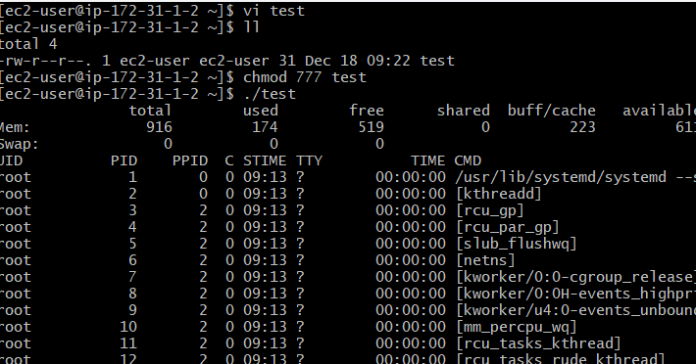
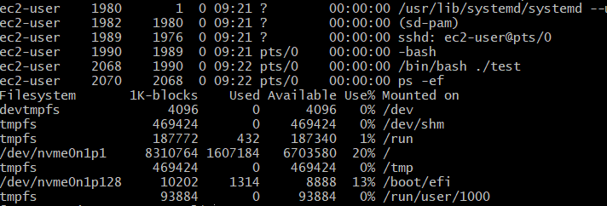
- Shell- Interface between our hardware and software
echo $0 to find our shell
To find types of shell – cat /etc/shells
To find which shell users assigned with
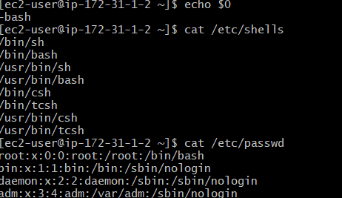
- We worked on bash scripting because it is a new feature of shell with enhancement (Bourn again shell)
To switch to different shells
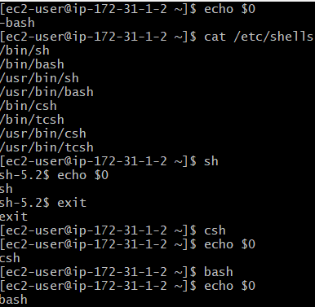
- How to run a script
- Absolute path
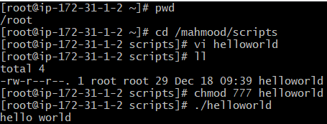
- Relative path
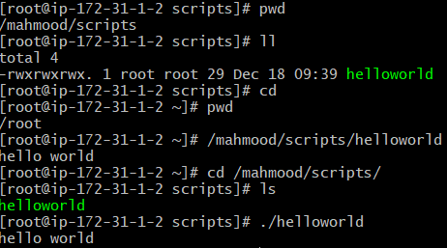
- Ways to execute script name
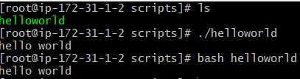
Bash filename – no needs for permissions
./filename – we need permissions
- Script naming conventions
- always create a directory to store scripts
- script name should identify the function
- script name should end with .shell
cd /Mahmood/scripts
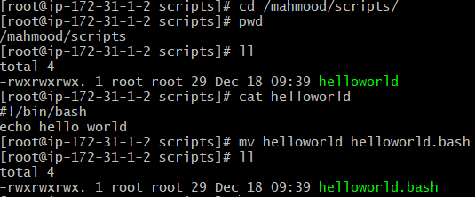
- Script File Permission
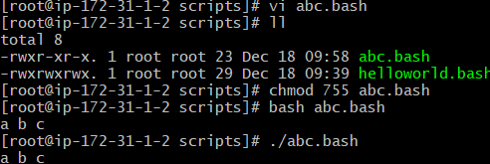
- Script format
Steps which will help the other user to understand our script easily
- Define shell (#!/bin/bash)
#! -shebang character
/bin/bash – shell we are using
- Comments (#comments)- which helps us to understand what we are doing
- Define variables (eg name =Mahmood) – which helps us to store any data a=‘hello word’
- Commands 9echo,cp,grep etc) – echo $a
-Statements (if,while,for etc) 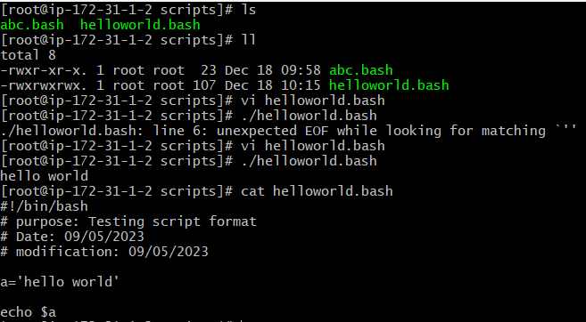
- Sequence Script- script will execute from top to bottom
- Basic script
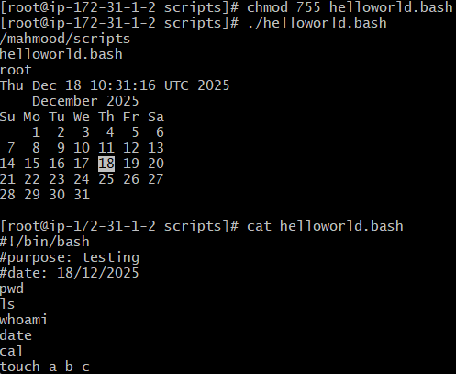
- Basic administration tasks
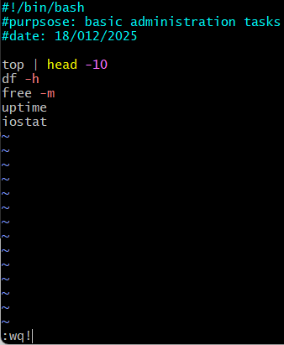
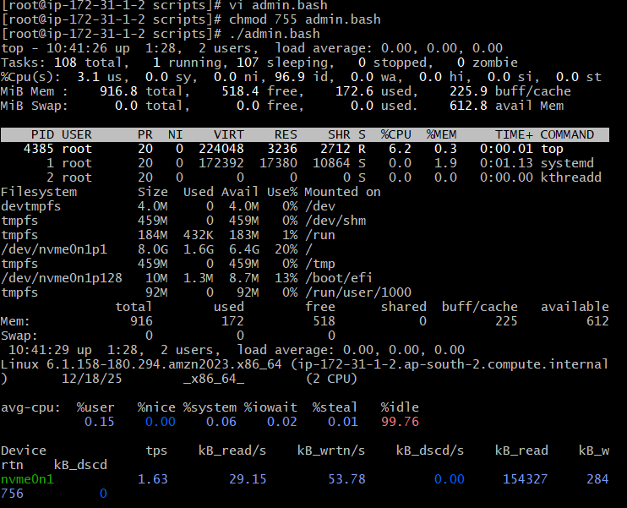
- Define variables – In programing a variable is a value that can change, depending on conditions or on information passed to the program
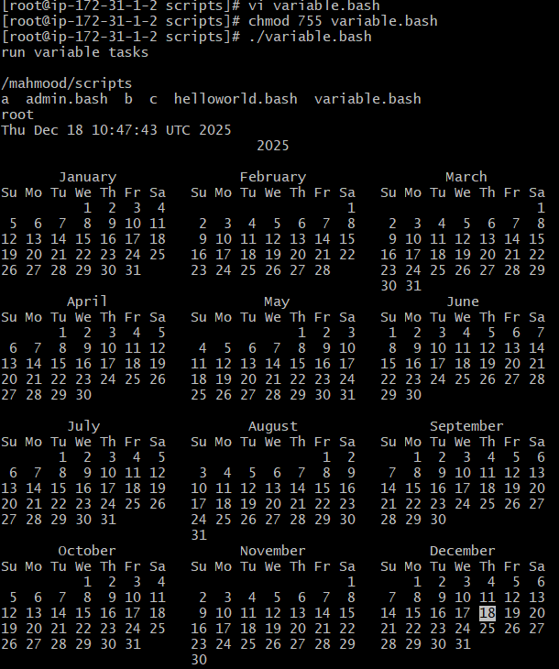
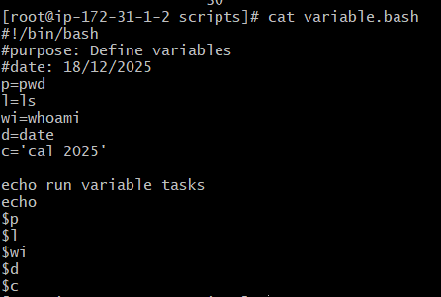
- Input/Output Script :
- Read – To take command from user
echo – To print the output
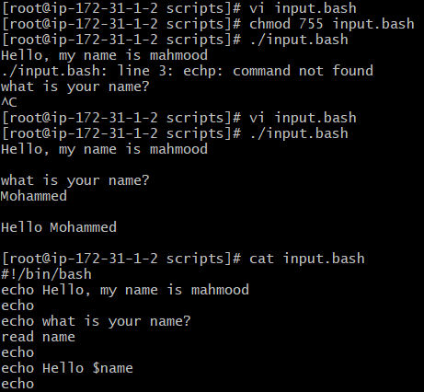
- 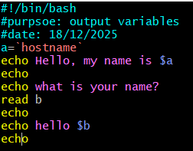
- 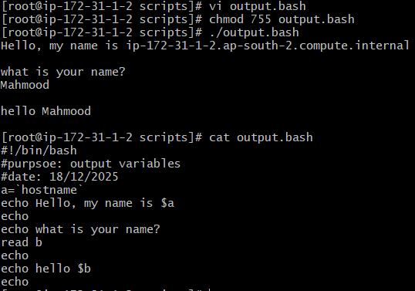

BASIC SHELL SCRIPTS
- Out put to screen
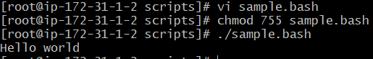
- Defining Tasks
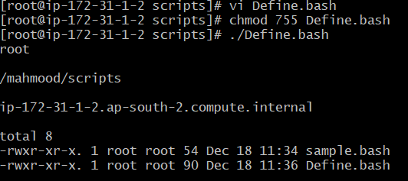
- Define variables
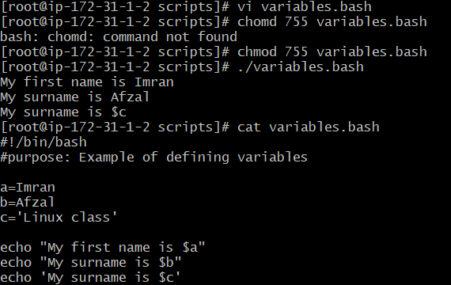
- Read Input
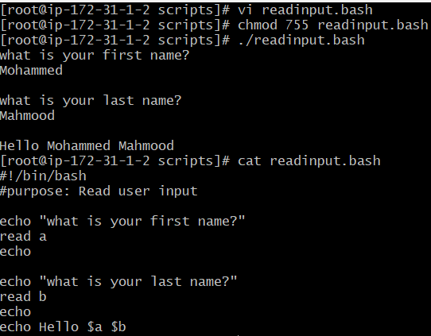
- Scripts to run commands within
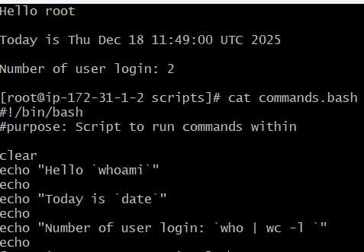
- Read input and perform a task
